**Potential Safety Improvements for Route 1 From East Machias to Calais**

**(For FHWA RURAL Grant Application)**

Summary of Annual Safety Benefits

The following table shows a summary of the calculated safety benefits that could be added to a potential roadway project on Route 1 from East Machias to Calais:



MaineDOT Safety Engineering has calculated a potential annual safety benefit of $3.88 million if all of the listed potential improvements are completed. The rest of this white paper goes into detail about the corridor crash screening to find “hot spots”, the types of safety improvements listed, and where the safety office recommend the improvements.

**Outline**

* Corridor Screening
  + Went Off Road Crash 0.5 Mile “Hot Spots”
    - 10-Year Total
    - 10-Year Injury
    - 5-Year Total
    - 5-Year Injury
  + Excess Crash “Hot Spots” – Minimum 20% Lane Departure Crashes
    - 5-Year
  + Horizontal Curve Screenings
    - Advisory Speed Less Than Speed Limit
    - Most Lane Departure Crashes – 5-Year
    - Most Winter Road Surface Crashes – 10-Year
  + Visually Inspect Lane Departure GIS Screening Tool – Look for clusters of these crashes to make spot improvements
  + Intersection Crash Screening
* Potential Safety Improvements
  + Rumble Strips
    - Centerline Rumble Strips
    - Shoulder Rumble Strips
  + Road Weather Information Systems (RWIS)
    - Install RWIS Station for Enhanced Winter Storm Response
    - Install Icy Curve Warning Systems
  + Install New or Extend Existing Guardrail
  + Tree Clearing
  + Upgrade Curve Signage
  + Correct Curve Superelevations
  + Other Potential Safety Improvements (Not Quantified)
    - Install Retroreflective Markers to Utility Poles
    - Install Changeable Message Boards Along Corridor
    - Install Enhanced Flashing School Zone Signage
    - Improve Pedestrian Crossings and Signing
    - Minor Intersection Improvements

**Corridor Screening**

The MaineDOT Safety Engineering group reviewed the corridor for locations within the 55 miles which could benefit from safety improvements. The following sections summarize the different screening methods used and the results of screening. Lane departure crashes (particularly went off road crashes) are the highest safety concern in the proposed project area. Lane departure crashes make up 87.6% of the crash costs over the last 10 years for the portion of the potential project south of “downtown” Calais.

**Went Off Road Crash 0.5 Mile “Hot Spots”**

A sliding half-mile screening process was used to find the highest went off road crash locations in the higher speed area between East Machias and Calais. This process was completed for total went off road crashes and went off road injury crashes. The screening was completed using 10-year data from 2012 to 2021 and 5-year data from 2017 to 2021. Some mile points show distances greater than 0.5 miles if the adjacent road segments were tied for the most went off road crashes.









**Excess Crash “Hot Spots” – Minimum 20% Lane Departure Crashes**

The new rural roadway segment highway safety manual screening was used to evaluate excess crashes along the proposed project over a 5-year period. A minimum of 20% observed lane departure crashes from 2017 to 2021 was used to avoid targeting segments without significant roadway departures.



**Horizontal Curve Screenings**

A high percentage of lane departure crashes and fatal/serious injuries occur on horizontal curves. MaineDOT has extensive horizontal curve data obtained using data from the ARAN vehicle. The following table shows curves with calculated advisory speeds less than the speed limit. Probe speed data has not been used to evaluate 85th percentile speeds through these curves at this point, but Safety Engineering is assuming the values will be more than 5 mph greater than the speed limit in the low-volume rural areas.



The next two tables rank horizontal curves based on observed crash data. The first table shows the curves with the most lane departure crashes from over 5 years from 2017 to 2021. The second table shows the curves with the most winter road surface condition crashes over 10 years from 2012 to 2021.





**Visually Inspect Lane Departure GIS Screening Tool – Look for clusters of these crashes to make spot improvements**

MaineDOT Safety Engineering created a GIS tool to screen lane departure crashes in the proposed project area. This tool can filter crashes by year, injury severity, and sequence of events.

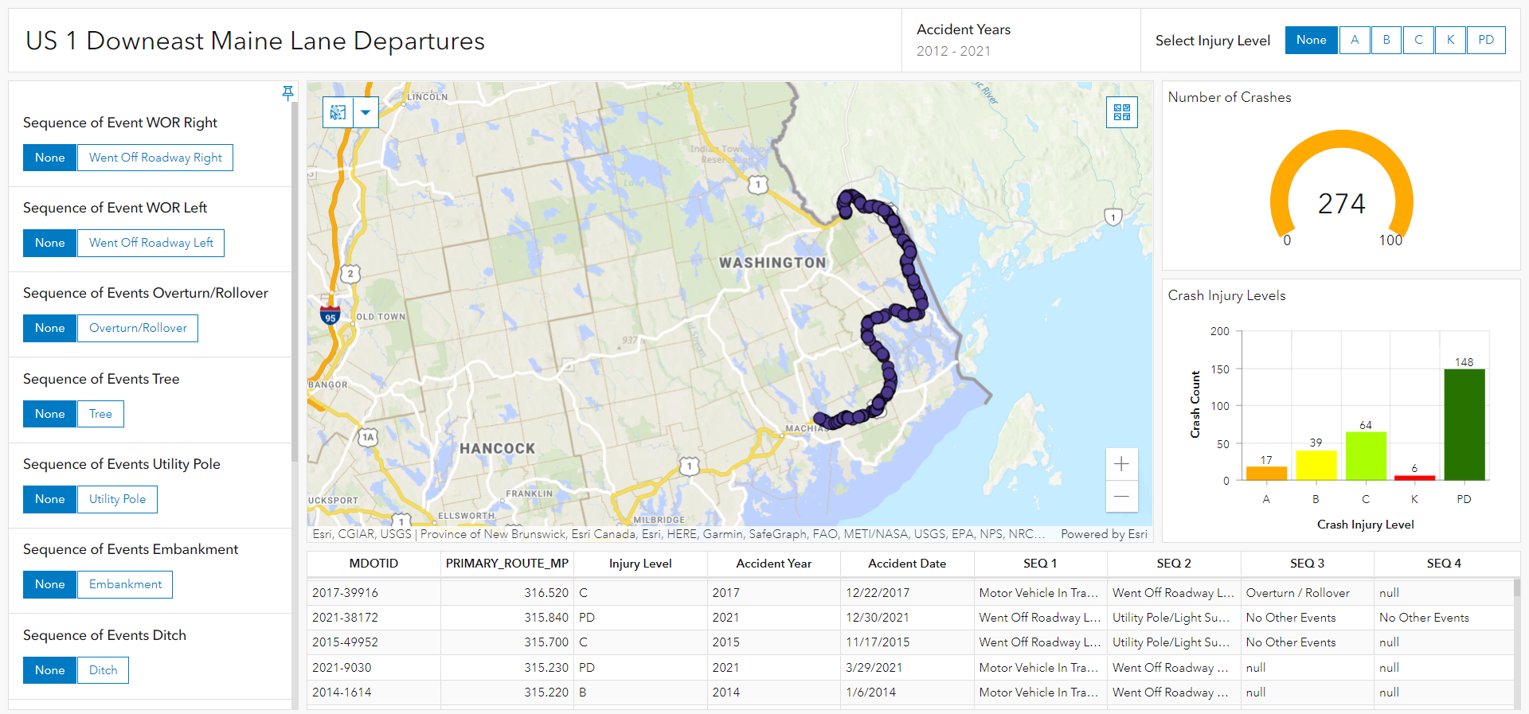

This tool was used to screen for areas while high rates of select crash types and severities. Most significantly, this tool was used to find clusters of tree crashes, overturn/rollover crashes, and crashes with injury severity minor injury or worse.

**Intersection Crash Screening**

Safety Engineering has a comprehensive intersection screening list containing all of the intersections across the state. Using this tool, we reviewed the 105 intersection on Route 1 in the proposed project area. A screenshot showing part of this tool is shown below:

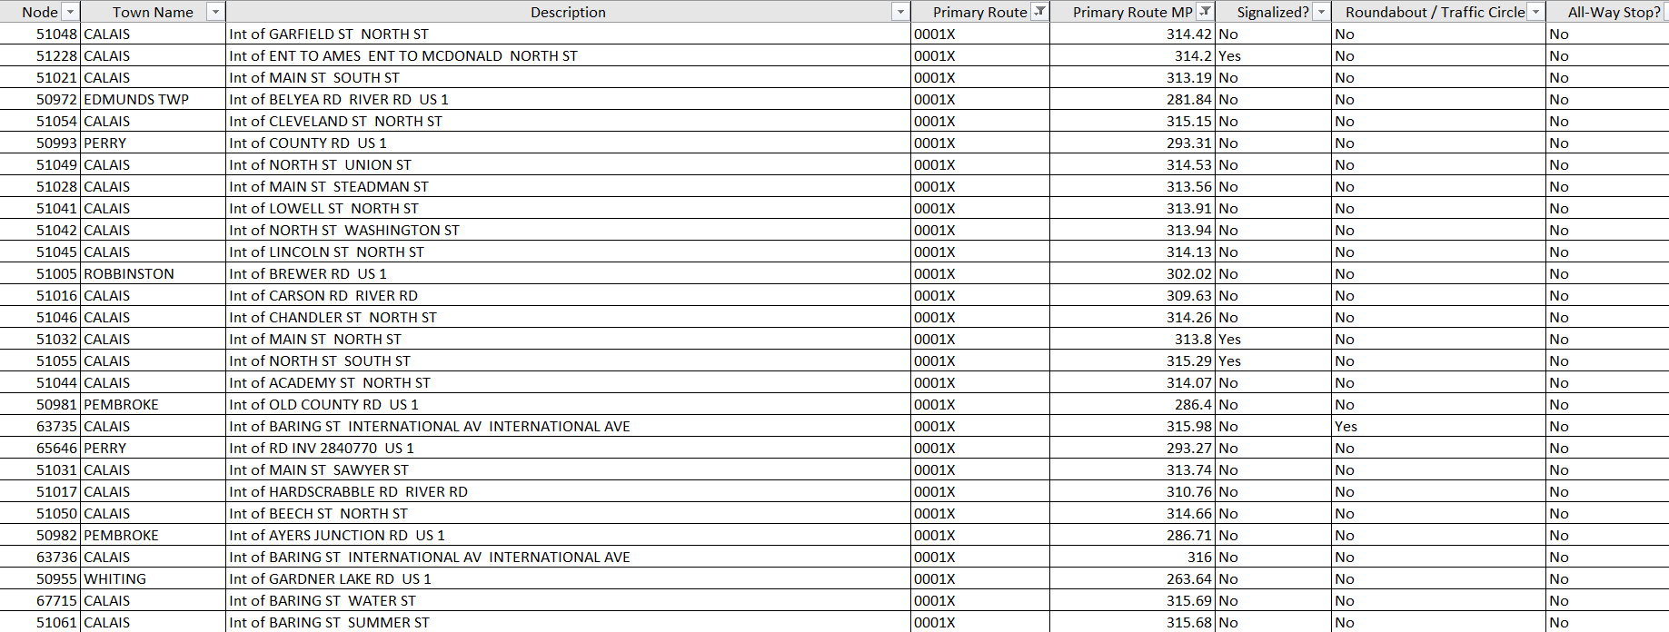

Based on this intersection screening, the following was determined:

* None of the intersections are ranked in the top 800 intersections for 3-year excess crashes
* There have not been any intersections on the High Crash location list since 2013
* None of the intersections have more than one fatal or serious injury crashes in the last 10 years
* None of the intersections have more than one crash containing a minor injury or worse in the last 5 years.
* There is only one coded ran stop sign crash among all of the intersections in the study area since the start of 2017.

Intersection crashes make up a small percentage of the crash costs for the Route 1 corridor in the study area.

**Potential Safety Improvements**

The Safety Engineering group review the project area to come up with potential safety improvements that could be added to the scope of this project. The focus of this was to reduce total crashes and crash severity with a primary focus on reducing lane departure crashes. The following sections describe potential safety improvements and the locations within the project where we think the improvements could be beneficial after our initial review.

**Rumble Strips**

Centerline rumble strips are a systemic safety improvement that MaineDOT has installed frequently in recent years on rural high-speed arterials. Shoulder rumble strips have been used on Maine’s interstate and expressway system for many years. They have been used scarcely to this point on arterials across the state.

Centerline Rumble Strips

According to the MaineDOT Map Viewer application, some of the study area had rumble strips installed in 2021 and there is more scheduled, but some stakeholders would like to wait for the next highway treatment before adding more rumble strips.

The safety analysis assumes that centerline rumble strips would be installed for proposed mileage of Route 1 south of “downtown” Calais where the speed limit is at least 45 mph. This adds up to about 47 miles.

Shoulder Rumble Strips

To reduce went off road right crashes on the corridor, Safety Engineering completed a safety analysis assuming shoulder rumble strips would be installed on the same mileage as centerline rumble strips. Our current thought is that the shoulder rumble strips could be milled into the pavement as close to the edge of pavement as possible to maximize the cross-sectional distance between the centerline and shoulder rumble treatments. This is being considered partially to reduce rumble strip hits by large trucks off-tracking through horizontal curves. A policy will have to be created describing the best practices for installing shoulder rumble strips on arterials with centerline rumble strips. These discussions may change the cross-sectional location where rumble strips are milled. It is also possible for shoulder or edge line rumble strips to be installed without centerline rumble strips. It is important to note that shoulder rumble strips alone are unlikely to reduce head-on crashes.

The centerline and shoulder rumble strip safety benefits have been calculated based on a Minnesota study where centerline and shoulder rumble strips were installed together on 2-lane rural roads. This study assumes that the centerline rumble strips reduce head-on crashes by 36% and the shoulder rumble strips reduce went off road crashes by 32%. The following are the estimated annual safety benefits for centerline rumble strips and shoulder rumble strips:

* Centerline Rumble Strips – $240,186.91
* Shoulder Rumble Strips – $1,585,579.84

**Road Weather Information Systems (RWIS)**

The MaineDOT Intelligent Transportation Systems (ITS) group has installed many Road Weather Information Systems (RWIS) on the interstate in recent years. These systems communicate with MaineDOT Headquarters to provide real time weather data such as temperature, visibility, road surface condition, grip, wind speed, etc. They also help forecast upcoming storms so maintenance crews are prepared and can respond to high-risk areas close to the start of a storm. These systems can also be connected to changeable message boards or actuated signs to automatically trigger a warning message to drivers or apply a storm-based reduced speed advisory.

The ITS department is looking to expand their RWIS program beyond the interstate to include high-priority, high-speed arterials. When Safety Engineering discussed this corridor with the ITS department, ITS indicated that they would be interested in an RWIS covering the area. They also noted that they may be interested in some select icy curve warning signs actuated by simplified RWIS sensors.

Install RWIS Station for Enhanced Winter Storm Response

During our crash data review, it became clear that there is a relatively high number of winter road surface crashes on Route 1 in the town of Whiting. According to MaineDOT’s Map Viewer application, Whiting is on the edge of coverage area for its assigned plow crew. This may mean that an RWIS station with advanced and real-time storm communication to maintenance could reduce storm response time. Based on a brief literature review, Safety Engineering assumed that an RWIS could conservatively provide accurate storm and weather information over 15 miles (7.5 miles in each direction). If this system was placed somewhere near the middle of Whiting, it could cover the southernmost 15 miles of the study area including all of Whiting as well as parts of East Machias and Edmunds Township. See the potential RWIS coverage area highlighted blue in the following image. The map in this image is also overlayed with winter road surface crashes since the start of 2012.

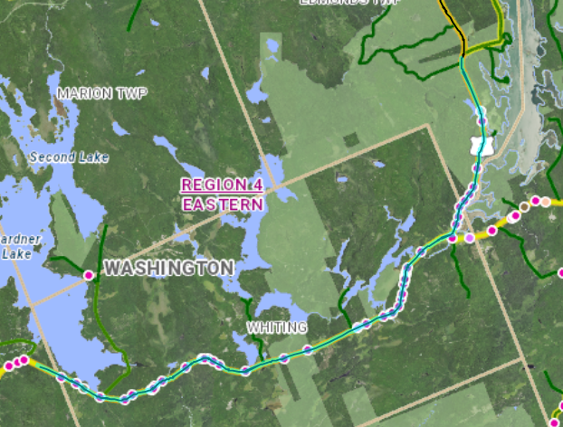

Safety Engineering is assuming an 11% reduction in injury crashes and a 27% reduction in property damage in the projected RWIS coverage area. This is based on a study to raise the standard by one class for winter maintenance. This study applies based on the way an RWIS would be used and even a top maintenance priority arterial would become in a class of its own once an RWIS is in place. These numbers seem reasonable based on an Idaho Study that showed a 51% reduction in winter road surface crashes at 33 locations where RWIS were installed between 2010 and 2013.

The estimated annual safety benefit for an installing an RWIS station is $263,097.03.

Icy Curve Warning System

Icy curve warning systems use simplified RWIS sensors to actuate flashing signs which warn approaching drivers when there is ice on the roadway through the horizontal curve. Using previously referenced corridor screening, Safety Engineering determined that the optimum curves to install this technology are as follows:



The estimated annual safety benefit for installing icy curve warning systems is $95,248.43.

**Install New or Extend Existing Guardrail**

There are certain areas of this study area which have experienced higher rates of crashes minor injury or worse. In most cases, vehicles are running off the road and striking embankment/ledge or overturning on the roadside. Safety Engineering has the idea to install or extend guardrail to reduce the severity of crashes at these locations. For most rural cases, went off road crashes that do not hit guardrail have higher average severity that do hit guardrail. The following statistics apply to rural arterials in Maine with speed limits 45 mph or higher:

* Went off road crashes that do not hit guardrail are 30% more likely to lead to an injury than went off road crashes that hit guardrail.
* Went off road crashes that do not hit guardrail are 36% more likely to lead to a minor injury or worse than went off road crashes that hit guardrail.
* Went off road crashes that do not hit guardrail are 2.14 times more likely to lead to a fatal or serious injury than went off road crashes that hit guardrail.

Safety Engineering identified the approximate miles of Route 1 which could benefit the most from additional guardrail. The following miles have been identified based on corridor screening for minor injury or worse crashes, overturn/rollover crashes, and embankment/ledge crashes:



The locations listed add up to about 4 miles where additional guardrail is recommended.

To analyze the safety impact of adding guardrail, Safety Engineering assumed a 6% increase in total crashes which appears to be conservative based on a comparison of other studies. A 27% reduction in minor injury or worse (K, A, and B) crashes was also assumed where guardrail was installed. The state specific data indicates a more significant change in crash severity is likely, so the 27% reduction is conservative as well since.

The estimated annual safety benefit for installing and expanding guardrail at select locations is $1,307,968.63.

**Tree Clearing**

The GIS sequence of events screening tool was used to identify locations within the study area with clusters of tree crashes. Went off road tree crashes are one of the most severe crash patterns and sometimes tree crashes crash frequency or severity can be reduced by removing trees on the roadside.

Safety engineering recommends spot tree clearing to the right of way at the following Route 1 mileage:



The locations listed add up to about 1.2 miles where tree clearing is recommended.

The safety analysis has been calculated assuming a 38% reduction in crashes based on a study for removing or relocating fixed object out of the clear zone.

The estimated annual safety benefit spot tree clearing is $187,981.79.

**Upgrading Curve Signage**

MaineDOT Safety Engineering identified 8 curves that could benefit from increased curve signing and markings based on horizontal alignment and crash history. The following table details the curve locations and recommended curve signing and marking enhancements.



The safety analysis has been calculated assuming an 18% reduction in crashes based on a study for general curve delineation improvements.

The estimated annual safety benefit for upgrading curve signing is $152,031.74.

**Correct Curve Superelevations**

MaineDOT’s curve data provides the superelevation for the curve in the ARAN travel direction as well as the recommended design superelevation. Safety Engineering identified 27 curves where the superelevation is lacking by 1% or more. These superelevations can potentially be corrected using shim pavement and milling. The assumed crash reduction for correcting these superelevations is curve specific and ranges from 0.1% to 11.4%.

The estimated annual safety benefit for correcting superelevations is $44,576.48.

**Other Potential Safety Improvements (Not Quantified)**

There are other potential safety improvements along the corridor that Safety Engineering has not quantified to this point.

Install Retroreflective Markers to Utility Poles

MaineDOT is looking into installing reflective markers on utility poles to reduce utility pole crashes and improve visibility of rural roads at night. There have been many utility pole crashes in the study area over the last 10 years, so this may be a good location to install them. Safety Engineering does not know how to quantify the safety impact of this improvement at this point.

Install Changeable Message Boards Along Corridor

There are many changeable message boards around the state that MaineDOT remotely connects to and regularly changes the messages. These signs can be used to warn about upcoming crashes, winter road conditions, create variable advisory speed limits, and share messages to discourage distracted driving, drowsy driving, as well as drinking and driving. MaineDOT Eastern Region Traffic Engineering were receptive to this idea, but Safety Engineering is not able to quantify the a safety benefit for installing changeable message signs at this point. One encouraging report from Michigan showed 16% lower crash rates on corridors where changeable message signs were installed.

Install Enhanced Flashing School Zone Signage

There are numerous school zones along Route 1 in the study area and many of these schools are in high speed segments. MaineDOT Traffic Engineering provides intelligent school zone signage with flashing signs that are programmed by time and date to flash during official school zone times. Safety Engineering has not quantified this improvement to this point, but it would be advisable to coordinate with Traffic Engineering about this topic.

Improve Pedestrian Crossings and Signing

Based on imagery, there are some crosswalks on Route 1 in Calais without pedestrian signing. If this project is selected, all crosswalks should be signed properly with ADA compliant curb tip-downs.

Minor Intersection Improvements

None of the intersections in the study area currently rise high on the statewide network screening for safety improvements. There may be opportunities to improve intersections in the study area at a low cost that could increase the total safety benefit of the project.